Name of the project:

Name of the applicant:

Unit/Institute:
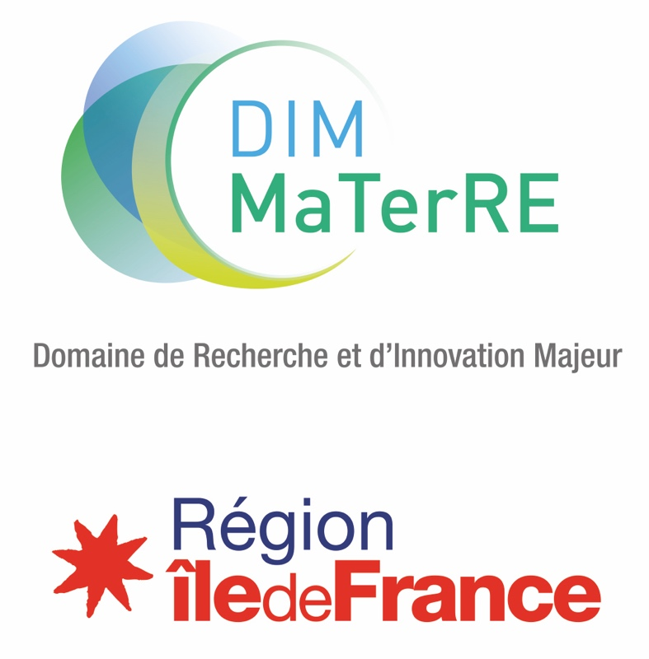

2023 CALL FOR PROPOSALS
Doctoral and postdoctoral grants

Deadline: 6th February 2023 at 23:59.

Files should be submitted on the dedicated platform at the following address: https://materre-2023-1.sciencesconf.org

Contact : dim-materre@espci.psl.eu
ELIGIBILITY
Eligible projects are carried out between team members of labs working on MaTerRE axes. Any Paris Region lab is eligible, without prior affiliation to the DIM. The submission of a project will be considered as an application for affiliation to the DIM.
Post-doctoral proposal (max. 60k€) as well as doctoral proposal (max. 125k€) can be submitted.
THEMES
The DIM MaTerRE is centered around four thematic axes, corresponding to current scientific, technological and societal challenges:
  - Capture, Production and Valorisation of strategic gases (CO₂, H₂…).
  - Eco-compatible Energy Storage or recovery.
- Construction materials.
  - Recycling, eco-design, sustainable materials, urban mining
This is complemented by 5 transverse methodological axes, including High-throughput methodologies (microfluidics…), Architected and multiscale materials, Advanced characterization techniques, numerical methods (databases, artificial intelligence, numerical modelling, simulations…), Economics of the energy transition
Proposals funded by MaTerRE have to fit within at least one, preferably two, of these axes.
EVALUATION CRITERIA
The evaluation criteria are the following:
  - Novelty and quality of the collaboration, in terms of complementarity and expected synergy. The project must associate the skills of at least two laboratories relevant for MaTerRE.
  - Innovative aspect of the project and collaboration with regard to the state of the art. Risk taking is encouraged.
  - Scientific and technical quality of the project.
At equal scientific quality, projects with co-financing will be favored.
CALENDAR
6 February 2023 at 23:59: Deadline for proposal submission (https://materre-2023-1.sciencesconf.org/).
Mid April – Mid May Audition of the preselected project leaders.
Before end of May 2023: Publication of the results. Final decision will depend on regional allowance.
LANGUAGE & FILE NOMENCLATURE
Projects must be written exclusively in English. Files must be named according to the following these rules : PROJECTSHORTNAME_PROJECTLEADERNAME_FILENAME. An illustration is mandatory.
IDENTIFICATION OF THE PARTNERS

 | Lab name, number and address | Team name | Name (first, last) of the project leader | Email | Phone number
Leader
Partner 1
Partner 2
…
Please attach a short resume (max 1 page, including experience, expertise, responsibilities, list up to 5 recent publications, main projects…) of each project leader.

Have the teams already worked together?
☐ Yes ☐ No

If yes, which one(s) and on which occasion? Indicate how far the proposed project differs from the previous collaborations (novelty, impact – maximum 5 lines).

If no, please highlight what makes the project unique and new in its kind (maximum 5 lines).

Please highlight the novelty and impact of the proposed project

List up to 5 major publications in the field, not necessarily from your teams (DOI link mandatory)

List of publications

Team members involved in the project

 | First names, Names | Emails
Leader
Partner 1
Partner 2

Thematic or transverse axis or axes concerned

Thematic axes

☐ Strategic gases

☐ Eco-compatible energies
☐ Construction Materials
☐ Recycling, eco-design, sustainable materials and urban mining

Transverse axes

☐ High-throughput

☐ Architected and multiscale Materials

☐ numerical methods

☐ Advanced characterization

☐ Economics

SCIENTIFIC DESCRIPTION OF THE PROJECT
(3 pages, Times 11)
Title of the project
Key Words
Public summary (for communication purpose)
For communication purpose, join as attachment a 300 dpi graphical illustration to the proposal.
Scientific description of the project; state of the art, innovative character, risks, expected results
Methodology, justification of budget and time frame
Adequacy to the objectives and integration to the MaTerRE project
Added value for Paris Region
Please indicate the expected impacts if the objectives are reached, and the collaborations established in Paris Region

FUNDING SCHEME

Type of grant

Doctoral Thesis

Doctoral Thesis in co-supervision

Post-doc
Amount of funding requested

☐ Full funding

☐ Partial funding

Lump support (equipment only ; max. 20k€ and 60% of the total amount)

☐ Yes

☐ No
Enclose at least one quote (except for internal development)

Host institution in charge of the management of the applied grant and of the working contract of the candidate.

Envisioned project co-financing.
Please indicate the amount and % of the total cost for each sponsor. If possible, and if the project is pre-selected, engagement letters should be presented for the auditions.
Post-doctoral funding
Heading | Acquired | Submitted | % of the total | Amount
MaTerRE |  | X |  | - €
Cofunding 1 : |  |  |  | - €
Cofunding 2 : |  |  |  | - €
 |  |  |  | - €
Total cost |  |  |  | - €

Lump support (equipment)
Heading | Acquired | Submitted | % of the total | Amount
MaTerRE |  | X | [60% max] | [Max 20k]- €
Cofunding 1 : |  |  |  | - €
Cofunding 2 : |  |  |  | - €
 |  |  |  | - €
Total cost |  |  |  | - €

EVALUATION

Suggested experts for peer review (from outside Paris Region, without common publications with any of the project partners during the past five years)

Unwanted experts (argue)

SIGNATURES

Signature of the project leader

First name, Last name
Position
In
The

Visa / Signature of the unit director
First name, Last name
Position
In
The
Signatures are required for the proposals to be accepted.

ANNEX: GENERAL RULES OF THE CALL FOR PROPOSALS MATERRE

Advertency : These rules are likely to be enriched or clarified, on the basis of Region rules, between now and the award of projects.

The objective of MaTerRE is to generate breakthroughs in sustainable materials for the energy transition, both fundamental and applied, by promoting interactions between specialists from different disciplines.
The aim of the call for proposals is to promote innovative, disruptive projects by creating synergies between laboratories.
All the Paris Region teams working in the fields listed in MaTerRE are eligible to respond to the call for proposals (CFP).
In the case where a team applies for several proposals, MaTerRE requests that the unit director in the team establishes a ranking of the proposals.
The proposals will be selected in a two-stage process:
- Preselection based on the submitted document.
- Selection after audition of the project leader.
The selection of proposals will be organized by MaTerRE's steering committee, supported by a jury including experts from outside Paris region.
To be eligible for a doctoral grant of a maximum duration of 36 months, students must hold a master degree and be enrolled in a doctoral school in Paris region. The Region favors the use of the doctoral contract (contrat doctoral) for the recruitment and financing of doctoral students.
To be eligible for a postdoctoral allocation for a period of 12 months, applicants must hold a doctoral degree.
The proposal must not have been financed by the Region as part of the support for collaborative projects of a competitiveness cluster, nor by another DIM or any other regional funding scheme.
The submitted scientific proposal must not have been proposed in any other DIM’s call for proposals.
FINANCING
The allowance may take into account the salary including all social contributions and the compensation for possible loss of employment. Any management costs of the beneficiary institutions are not eligible for funding.
It will be possible to apply proposals co-financed by one or more partners. The letter of commitment of the co-funder(s) should be presented during the auditions.
Post-doctoral and doctoral grants may be subject to lump sum support in small equipment cofinancing for a maximum amount of 20k€ and a maximum rate of 60%.
PhDs will be funded for a maximum of 125k€.
Post-doctoral contracts will be funded for a maximum of 60k.

ENGAGEMENT OF THE TEAMS

The recipient teams of a grant of the Paris Region, within the framework of a MaTerRE Call for Proposals, commit to, in particular:
- To read and respect the regional and MaTerRE rules.
- To transfer the progress report (s), the activity report of the project or any other document at the request of the administrative department of the ESPCI, MaTerRE's managing institution, respecting the indicated deadlines and document formats.
- To indicate, in the context of any written publication (article, proceedings ...), the following thank-you text: "This work has been sponsored by the Ile-de-France Region in the framework of MaTerRE”.
- To display, as part of any oral communication (conference, seminar, workshop, school ...) the logo of the Ile-de-France Region and that of MaTerRE and its guardianships.

See details in annex.

